

**A Report on Developing Intelligence IQ vs EQ**

**Course: Professional Practices**

**Timing: Tuesday (3:10-5:10)**

|  |
| --- |
| Group Members: |
| Muhammad Arsalan (34625) |
| Muhammad Arsalan (35162) |
| Muhammad Arbaz Shahid (34630) |
| Muhammad Huzaifa Khan (34856) |
| Muhammad Usama Sohail (34836) |
| Sarah Anwar (34822) |

|  |
| --- |
| Submitted To: |
| Dr. Salima Ahsan |

**Table of Content**

|  |
| --- |
| What is Intelligence |
| Types of Intelligence |
| Intelligence Quotient IQ |
| Definition of IQ |
| Example of IQ |
| What Research says |
| Importance of IQ |
| Signs of High and Low IQ |
| How to Raise your IQ |
| How does your IQ helps you to success |
| Emotional Quotient EQ |
| Definition of EQ |
| Example of EQ, |
| Five Categories of Emotional Quotient |
| Spectrum of Emotional Quotient |
| Importance of EQ |
| Signs of High and Low EQ |
| How to Raise your EQ |
| How does your EQ helps you to success |
| Comparison between IQ vs EQ |
| Teachers Role in IQ and EQ |
| How Teacher can influence the EQ and IQ of the students |
| How teachers can achieve the balance between EQ and IQ? |
| How teachers can help the students to achieve the balance between EQ and IQ? |
| Challenge yourself to achieve |
| Conclusion |
| References |

**Intelligence**

**What is Intelligence?**

***Intelligence*** *is a mental quality consisting of the ability to learn from experience, solving problems, and use of knowledge to adapt new situations.*

***“The true sign of intelligence is not knowledge but imagination”***

***By******Albert Einstein***

OR

The ability to acquire and apply knowledge and skills.

As we all know that intelligence it consist of different types, so they are discussed below:

**Types of Intelligence**

There are nine types of intelligence:

1. **Natural Intelligence:**

Naturalist intelligence designates the human ability to discriminate among living things (plants, animals) as well as sensitivity to other features of the natural world (clouds, rock configurations).

1. **Musical Intelligence:**

Musical intelligence is the capacity to discern pitch, rhythm, timbre, and tone. This intelligence enables us to recognize, create, reproduce, and reflect on music, as demonstrated by composers, conductors, musicians, vocalist, and sensitive listeners. Interestingly, there is often an affective connection between music and the emotions; and mathematical and musical intelligences may share common thinking processes. Young adults with this kind of intelligence are usually singing or drumming to themselves. They are usually quite aware of sounds others may miss.

1. **Logical Mathematical Intelligence:**

Logical-mathematical intelligence is the ability to calculate, quantify, consider propositions and hypotheses, and carry out complete mathematical operations. It enables us to perceive relationships and connections and to use abstract, symbolic thought; sequential reasoning skills; and inductive and deductive thinking patterns. Logical intelligence is usually well developed in mathematicians, scientists, and detectives. Young adults with lots of logical intelligence are interested in patterns, categories, and relationships. They are drawn to arithmetic problems, strategy games and experiments.

1. **Existential Intelligence:**

Sensitivity and capacity to tackle deep questions about human existence, such as the meaning of life, why we die, and how did we get here.

1. **Interpersonal Intelligence:**

Interpersonal intelligence is the ability to understand and interact effectively with others. It involves effective verbal and nonverbal communication, the ability to note distinctions among others, sensitivity to the moods and temperaments of others, and the ability to entertain multiple perspectives. Teachers, social workers, actors, and politicians all exhibit interpersonal intelligence. Young adults with this kind of intelligence are leaders among their peers, are good at communicating, and seem to understand others’ feelings and motives.

1. **Body-Kinesthetic Intelligence:**

Bodily kinesthetic intelligence is the capacity to manipulate objects and use a variety of physical skills. This intelligence also involves a sense of timing and the perfection of skills through mind–body union. Athletes, dancers, surgeons, and crafts people exhibit well-developed bodily kinesthetic intelligence.

1. **Linguistic Intelligence:**

Linguistic intelligence is the ability to think in words and to use language to express and appreciate complex meanings. It allows us to understand the order and meaning of words and to apply meta-linguistic skills to reflect on our use of language. Linguistic intelligence is the most widely shared human competence and is evident in poets, novelists, journalists, and effective public speakers. Young adults with this kind of intelligence enjoy writing, reading, telling stories or doing crossword puzzles.

1. **Intra-Personal Intelligence:**

Intra-personal intelligence is the capacity to understand oneself and one’s thoughts and feelings, and to use such knowledge in planning and direction one’s life. Intra-personal intelligence involves not only an appreciation of the self, but also of the human condition. It is evident in psychologist, spiritual leaders, and philosophers.

These young adults may be shy. They are very aware of their own feelings and are self-motivated.

1. **Spatial Intelligence:**

Spatial intelligence is the ability to think in three dimensions. Core capacities include mental imagery, spatial reasoning, image manipulation, graphic and artistic skills, and an active imagination. Sailors, pilots, sculptors, painters, and architects all exhibit spatial intelligence. Young adults with this kind of intelligence may be fascinated with mazes or jigsaw puzzles, or spend free time drawing or daydreaming.

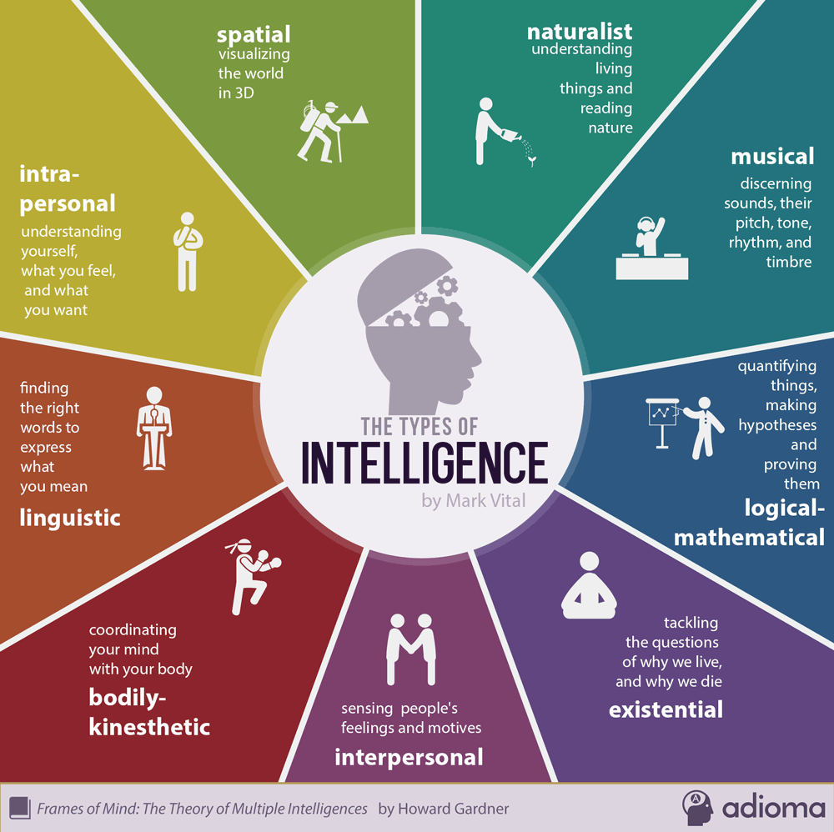

**Intelligence Quotient IQ**

The IQ is a measurement of your intelligence and is expressed in a number.

**Mathematical Expression:**

**IQ = $\frac{Mental Age}{Chronological Age}$ x 100**

**Example:**

Samuel had a high IQ. He could reason, was analytical and logical, and had a steel-trap focus on tasks. He learned new things quickly. However, he ignored how he was feeling and how others were feeling. If things didn't do the way he expected them to, he would lose his temper and lash out at others. He was unable to relate to people who weren't as smart as he was and lacked empathy. This limited his ability to be effective in team situations even though his IQ was very high.

**What Research Says…?**

**According to research:**

IQ can help you to be successful to the extent of 20% only in life.

The rest 80% success depends on EQ.

**80**

**%**

**EQ**

**20**

**%**

**IQ**

**“Your EQ has more to do with your success and happiness in life than your IQ and it can be learned. “**

**Importance of Intelligence Quotient**

IQ is still recognized as an important element of success, particularly when it comes to academic achievement. People with high IQs typically to do well in school, often earn more money, and tend to be healthier in general. But today experts recognize it is not the only determinate of life success. Instead, it is part of a complex array of influences that includes emotional intelligence among other things.

**Signs of High and Low IQ**

**HIGH IQ:**

* Signs that a person may have a higher than normal IQ may begin with early walking and talking, communication and social skills. He/she may also show a high energy level, interest in artistic activities, have rapid and complicated language patterns, as well as showing empathy with others and leadership among peers.

**LOW IQ:**

* Signs that a person may have a lower than average IQ begin with walking and talking later than his contemporaries. Other signs include poor social skills in play-learn situations with others, delayed self-care, hygiene, dressing and feeding skills. As the person gets older, difficulties in learning skills and poor job skills may also be indicators.

**How to raise your IQ**

There are numerous ways to raise the IQ level of any person, but some of them are given below:

* **Change the order:**

If we have notice that we do lots of things in a particular order. For Example, if we brush our teeth then hand will be same as usual, pocket of wallet will be the same. It means that you have to change the order means if you brush your teeth with left hand then do it from right hand. By doing this, mind will be active. The more your mind will active, the greater your IQ increase.

* **Eat breakfast:**

Eating breakfast has been proven to improve concentration, problem solving ability, mental performance, memory, and mood. Breakfast is the first chance the body has to refuel its glucose levels after eight to 12 hours without a meal. Glucose is the brain’s main energy source.

* **Expand your imagination:**

Make other’s imagination be the part of your imagination. The best way of doing this is reading Novel. Doing imagination on behalf of any small information, most of the experiments convert into reality.

* **Association:**

Link between the things. Normally we can easily remember things that are related to each other but difficult to remember different things. For example, if we say pencil, eraser, sharpener, and ruler so, these are related to each other. If we want to remember different things so, we should have to imagine and associate between them. This technique is called “Story Method” which help us to increase memory capabilities.

* **Retest yourself:**

Give the test which is related to your field such as Multiple Choice Questions. After completing it see how much correct and how much incorrect. Then give the same test again till all the answers will correct. By doing this your retention power will increase than you will have the ability to memorize things easily

* **Treat for your brain:**

For growing your IQ, mind and body both should be healthier. For this you must work out because heart pump blood more and brain gets more blood and brain gets energy. Keep remember “A healthy mind resides in a healthy body”

* **Take the right stress:**

Take the right stress which is beneficial to your mind. Remember that there are two types of stress.

* **Positive Stress**

Which is beneficial to you. For Example, Solving puzzle, playing mind games etc. By this, you’re thinking power increase and concentration power as well.

* **Negative Stress**

Which create negative impact on your health. For example, if you are already in a stress and you give stress on your mind then this will produce less focus on your mind and dilute our concentration power

**KEY: Consistency: -**

You need to be consistent because our mind need concentration. If you don’t use, you lose. Select 2 or 3 or possible all the activities and make them a part of daily routine. You can use reminder in your phone. But STAY CONSISTENT.

**How your IQ does helps you to success**

IQ is still recognized as an important element of success, particularly when it comes to academic achievement. People with high IQ typically to do well in school, often earn more money, and tend to be healthier in general. But today experts recognize it is not the only determinate of life success. Instead, it is part of a complex array of influences that includes emotional intelligence among other things.

**Emotional Quotient EQ**

**Emotional Quotient is defined as:**

* Knowing what feels good, what feels bad and how to get from bad to good.
* Knowing your emotions and knowing emotions of others
* It refers to emotional management skills which provide competency to balance emotions and reason so as maximize long term happiness.

**Example:**

Jose had a high EQ. He got along well with people, and managed his own emotions well. This made him highly effective in his work, even though there were others in the firm with higher IQs. Jose was able to consider the emotional component of interactions, using both his cognitive abilities and his understanding of emotions. He was able to influence and motivate people because he understood what mattered to them and was an excellent communicator. He was flexible and creative when faced with a challenge, and resilient in the face of temporary defeats. He was well-liked and well-respected.

**Five Categories of EQ:**

* **Self-Awareness:**

The ability to recognize an emotion as it “happens” is the key to your EQ. Developing self-awareness requires tuning in to your true feelings. If you evaluate your emotions, you can manage them. The major elements of self-awareness are:

* Emotional awareness. Your ability to recognize your own emotions and their effects.
* Self-confidence. Sureness about your self-worth and capabilities.
* **Self-Regulation:**

You often have little control over when you experience emotions. You can, however, have some say in how long an emotion will last by using a number of techniques to alleviate negative emotions such as anger, anxiety or depression. A few of these techniques include recasting a situation in a more positive light, taking a long walk and meditation or prayer. Self-regulation involves

* Self-control. Managing disruptive impulses.
* Trustworthiness. Maintaining standards of honesty and integrity.
* Conscientiousness. Taking responsibility for your own performance.
* Adaptability. Handling change with flexibility.
* Innovation. Being open to new ideas.
* **Motivation:**

To motivate yourself for any achievement requires clear goals and a positive attitude. Although you may have a predisposition to either a positive or a negative attitude, you can with effort and practice learn to think more positively. If you catch negative thoughts as they occur, you can reframe them in more positive terms — which will help you achieve your goals. Motivation is made up of:

* Achievement drive. You’re constant striving to improve or to meet a standard of excellence.
* Commitment. Aligning with the goals of the group or organization.
* Initiative. Reading yourself to act on opportunities.
* Optimism. Pursuing goals persistently despite obstacles and setbacks.
* **Empathy:**

The ability to recognize how people feel is important to success in your life and career. The more skillful you are at discerning the feelings behind others’ signals the better you can control the signals you send them. An empathetic person excels at:

* Service orientation. Anticipating, recognizing and meeting clients’ needs.
* Developing others. Sensing what others need to progress and bolstering their abilities.
* Leveraging diversity. Cultivating opportunities through diverse people.
* Political awareness. Reading a group’s emotional currents and power relationships.
* Understanding others. Discerning the feelings behind the needs and wants of others.
* **Social Skills:**

The development of good interpersonal skills is tantamount to success in your life and career. In today’s always-connected world, everyone has immediate access to technical knowledge. Thus, “people skills” are even more important now because you must possess a high EQ to better understand, empathize and negotiate with others in a global economy. Among the most useful skills are:

* Influence. Wielding effective persuasion tactics.
* Communication. Sending clear messages.
* Leadership. Inspiring and guiding groups and people.
* Change catalyst. Initiating or managing change.
* Conflict management. Understanding, negotiating and resolving disagreements.
* Building bonds. Nurturing instrumental relationships.
* Collaboration and cooperation. Working with others toward shared goals.
* Team capabilities. Creating group synergy in pursuing collective goals.

**Spectrum of Emotional Quotient**

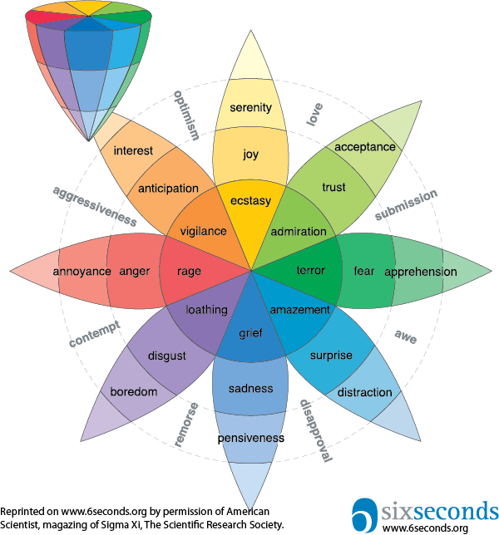

**The Emotional Intelligence Spectrum** explains how to improve your social skills in order to rapidly succeed in your professional and personal life; how to deal with people, connect with them and influence them.

**Importance of EQ:**

Emotional intelligence is a gateway to a balanced-life. It’s essential to basically every aspect of life.

**Physical Health:** The ability to take care of our bodies and specially to manage our stress, which has an incredible impact on our overall wellness, is heavily tied to our emotional intelligence.

**Mental Well-Being:** Emotional intelligence affects our attitude and outlook on life. It can also help to alleviate anxiety and avoid depression and mood swings. A high level of emotional intelligence directly correlates to a positive attitude and happier outlook on life.

**Relationships:** By better understanding and managing our emotions, we are better able to communicate our feelings in a more constructive way. We are also better able to understand and relate to those with whom we are in relationships. Understanding the needs, feelings, and responses of those we care about leads to stronger and more fulfilling relationships.

**Success:** Higher emotional intelligence helps us to be stronger internal motivators, which can reduce procrastination, increase self-confidence, and improve our ability to focus on a goal.

**Signs of High and Low EQ**

**HIGH EQ:**

A person with high IQ:

* Is not motivated by power, wealth, status, fame, or approval.
* Is emotionally resilient.
* Is optimistic; does not internalize failure.
* Is interested in other people's feelings.
* Is comfortable talking about feelings?
* Is not immobilized by fear or worry.
* Is able to identify multiple concurrent feelings.

**LOW EQ:**

A person with high EQ:

* Doesn't take responsibilities for his feelings; but blames you or others for them.
* Withholds information about or lies about his feelings. (Emotional dishonesty)
* Can't tell you why she feels the way she does, or can't do it without blaming someone else.
* Attacks, blames, commands, criticized, interrupts, invalidates, lectures, advises and judges you and others.
* Tries to analyze you, for example when you express your feelings.
* Lays guilt trips on you.
* Withholds information about or lies about his feelings. (Emotional dishonesty)

**How to raise your EQ**

* **Knowing one’s own emotions:**

Recognize and name emotions you feel; understand why you feel that way; and distinguish between feelings and actions

* **Motivating oneself:**

When considering how to productively harness your feelings, practice some emotional self-control and delay gratification

* **Recognizing emotions in others:**

Be sensitive to other people’s feelings and listen well

* **Managing emotions:**

Accept your feelings, but find a balance between over sensitivity or over expression and emotional suppression

* **Handling relationships:**

Being perceptive, applying conflict management skills instead of ignoring conflict, and being considerate and cooperative

**How your EQ does helps you to success**

* College interviews
* Internships
* Relationships with family and friends
* Career: Employers administer EQ tests before offering jobs
* Progress quickly thru life and achieve more!
* Ability to deal with your immediate world

**Comparison between IQ and EQ**

|  |  |
| --- | --- |
| IQ | EQ |
| IQ gets you through school | EQ gets you through life. |
| Trying to convince someone by facts alone | Appealing to reason and emotions to convince someone |
| Relying solely on your cognitive skills | Using your emotions as well as your cognitive abilities to function more effectively |
| Measure of ability to learn or understand | Measure of ability to use your emotions and logical skills |
| Makes one legal scholar | Makes one brilliant trial lawyer |

**Teachers Role in IQ and EQ**

**How Teacher can influence the EQ and IQ of the students?**

* Constantly showered their students with encouragement.
* While educating the students, teachers have to constantly upgrade themselves and continue to reflect and learn.
* By creating a conducive environment in the classroom.

**How teachers can achieve the balance between EQ and IQ?**

* By educating himself or herself about IQ and EQ.
* Teachers have to know the importance of balance between EQ and IQ.
* Teachers have to help educate the parents about the importance of balancing EQ and IQ.

**How teachers can help the students to achieve the balance between EQ and IQ?**

* By coaching and mentoring the students.
* By giving the students challenging assignments.
* By encouraging team building in classroom.
* Teacher should give positive feedbacks or response to the students.
* Teacher should educate the students about the important of EQ and IQ and the balance between EQ and IQ.
* Teachers have to be able to strike a balance between challenging a student, exposing him or her to new ideas and activities and try to have a meaningful and light hearted conversations with the students.

**Challenge yourself to achieve**

* It is not just technical and analytical abilities (IQ) that makes one successful
* To be successful in life, you need a combination of EQ and IQ.
* And here is the great news; EQ (unlike IQ) can be developed!

**Conclusion**

From the beginning till end we have learned about:

* Intelligence
* Intelligence Quotient(IQ) And Emotional Quotient(EQ)
* Comparison between IQ vs EQ
* Role of IQ and EQ in human life according to research.
* Importance of IQ and EQ
* Indications of high and low IQs , EQs
* Tips to raise IQ and EQ
* Role of IQ and EQ in leading success
* Teacher’s role in IQ and EQ

**References**

* [**https://www.livestrong.com/article/29064-signs-low-high-iq/**](https://www.livestrong.com/article/29064-signs-low-high-iq/)
* [**https://www.lifehack.org/articles/communication/emotional-intelligence-why-important.html**](https://www.lifehack.org/articles/communication/emotional-intelligence-why-important.html)
* [**https://daringtolivefully.com/increase-your-iq**](https://daringtolivefully.com/increase-your-iq)
* [**https://www.slideshare.net/a3mayank/eq-vs-iq-40786275**](https://www.slideshare.net/a3mayank/eq-vs-iq-40786275)
* [**https://studylib.net/doc/5416300/eq-vs.-iq-powerpoint**](https://studylib.net/doc/5416300/eq-vs.-iq-powerpoint)
* [**https://msu.edu/~kvampete/psy%20101%20-%20intelligence.pdf**](https://msu.edu/~kvampete/PSY%20101%20-%20Intelligence.pdf)
* [**https://www.123test.com/what-is-iq-what-is-intelligence/**](https://www.123test.com/what-is-iq-what-is-intelligence/)
* [**https://www.verywellmind.com/iq-or-eq-which-one-is-more-important-2795287**](https://www.verywellmind.com/iq-or-eq-which-one-is-more-important-2795287)
* **https://blog.adioma.com/9-types-of-intelligence-infographic**
* [**https://psychcentral.com/lib/what-is-emotional-intelligence-eq**](https://psychcentral.com/lib/what-is-emotional-intelligence-eq)
* **https://www.youtube.com/watch?v=ltZlyRUnklY**